**Software Development Plan Template**

**Website for blind**

**Blind Supporter**

**DATE:** 15/3/2023

**Presented To:**

Dr Mohamed Ramadan

**Submitted By:**

Bassem Ashraf **,**

Ahmed Kamal ,

Abdelsalam Mohamed

, Hosam Hassan

, Moaz ,

Mohamed Barakat**.**

**REVISION HISTORY**

| **Date** | **Author** | **Distributed to** | **Version** | **Description** |
| --- | --- | --- | --- | --- |
| DD\ MM\YYYY | name | who | Matches title page | Brief description of change |

**TABLE OF CONTENTS**

# 1. PRODUCT DESCRIPTION

# Description:

### A website for the blind is designed to provide an accessible and user-friendly experience for individuals with visual impairments and to help blind students face the consequences they face during study.

### The client, who is blind, faces many challenges when using traditional websites, as they may not be optimized for their needs. The potential audience for a website for the blind includes individuals who are blind or visually impaired.

## Goals:

### The goals of a website for the blind are to provide an accessible and inclusive experience for users, enabling them to navigate the web, find information, and interact with online services and products and ­Helping the blind student to study.

### Some of the major functionalities and salient features of a website for the blind might include:

### Alternative text for images: Providing alternative text for images allows users with visual impairments to understand what the image is depicting by screen reader.

### Screen reader compatibility: Ensuring that the website is compatible with screen reader technology allows users to access the website using audio output.

### Text-to-speech functionality: Providing text-to-speech functionality enables users to listen to the content on the website rather than reading it.

### High-contrast design: A high-contrast design can make the website more accessible for individuals with low vision.

### Simplified layout: A simplified layout with clear headings and content hierarchy makes the website easier to navigate.

### Audio descriptions: Providing audio descriptions for videos and multimedia content enables users to understand the content without visual cues.

### By providing these functionalities and salient features, a website for the blind can create an inclusive and accessible online experience for individuals with visual impairments.

## Problems:

### A website for the blind solves several problems that individuals who are blind or visually impaired may face when using traditional websites. Some of these problems include:

### Inaccessible images: Images on traditional websites may not have alternative text descriptions, which can make it difficult for individuals who are blind or visually impaired to understand the content.

### Poorly organized content: Websites that are not organized in a clear and logical way can be difficult for individuals with visual impairments to navigate.

### Incompatible technology: Some websites may not be compatible with screen readers or other assistive technology that individuals with visual impairments use to access the web.

### Unclear link descriptions: Links that are not clearly labeled can make it difficult for individuals with visual impairments to know where a link will take them.

### Small or difficult-to-read font: Websites with small or hard-to-read fonts can be a challenge for individuals with visual impairments.

**2. TEAM DESCRIPTION**

|  |  |
| --- | --- |
| Name | Skills |
| Bassem Ashraf | He takes database because he have more experience in my sql and AI. |
| Ahmed Kamal | He takes frontend because he have more experience in html ,css and js. |
| Abdelsalam Mohamed | He takes backend because he have more experience in paython and java and PHP |
| Hosam Hassan | He takes documentation because he have more experience in design and skills to collect information |
| Moaz | He takes Graphics because he have more experience in design and photoshope. |
| Mohamed Barakat | He takes frontend because he have more experience in html ,css and js. |

Is there a need for a Subject Matter Expert (SME)? Yes, There is expert on our project.

What expertise is missing? Yes, somethings

**3. SOFTWARE PROCESS MODEL DESCRIPTION**

Our Product is Agail because it is subject to change in terms of requirements and can be delivered quickly.

**4. PRODUCT DEFINITION**

The users of a website for the blind are individuals who are blind or visually impaired. This includes people with varying levels of visual impairment, from those who are completely blind to those who have low vision.

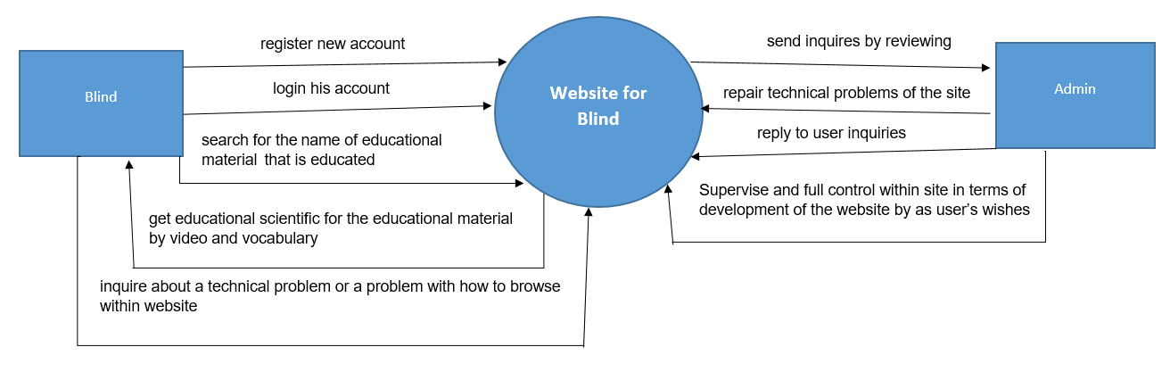**Context Diagram**

**Personas**

|  |  |  |  |
| --- | --- | --- | --- |
| User Persona | Who are they | What is their main goal | What is their main concern /barrier to achieve this goal |
| Blind | Is the user that the whole website is made for him and the website describes the services and Education process that it gives to him and according to his capabilities and abilities receive and perceive information | He browses on our website to get a study process in an easy way and in the way that suits him in terms of his capabilities. | Don’t know what is the appropriate way to learn the study materials easily and How to learn her. |
| Admin(programmer) | He is the technician, supervisor and controller of the site to solve technical problems and respond to user inquiries in guiding them on how to use and browse the site. | Solving technical problems, satisfying the customer, and facilitating the process of learning the educational materials. | It is possible that he does not understand what the problem that the user wants to solve by interpreting the problem in an incorrect way that he cannot understand. |

**User Stories**

**Blind:**

|  |  |
| --- | --- |
| **User**  **Story** | As a Blind  I want a service that ease to me learning and knowing how to get Make full useful of the educational materials and how to be happy for my experience and learning within site  So that I won’t need to inquiring admin about How use site |
| **Acceptance**  **Criteria** | * User can login in website as Blind. * User search about Name Educational Material. * User learns about Educational Material By watching videos, listening to audio clips. |

**Admin (Programmer):**

|  |  |
| --- | --- |
| **User**  **Story** | As a Admin (programmer)  I want to easy education process on blind and  so that I can get more customers and get customer satisfaction and happiness with the site |
| **Acceptance**  **Criteria** | * User can login in website as Admin * User repair and solve technical problems of the site. * User responses on problems which is written in Dialog Box within site by the blind by speaking. |

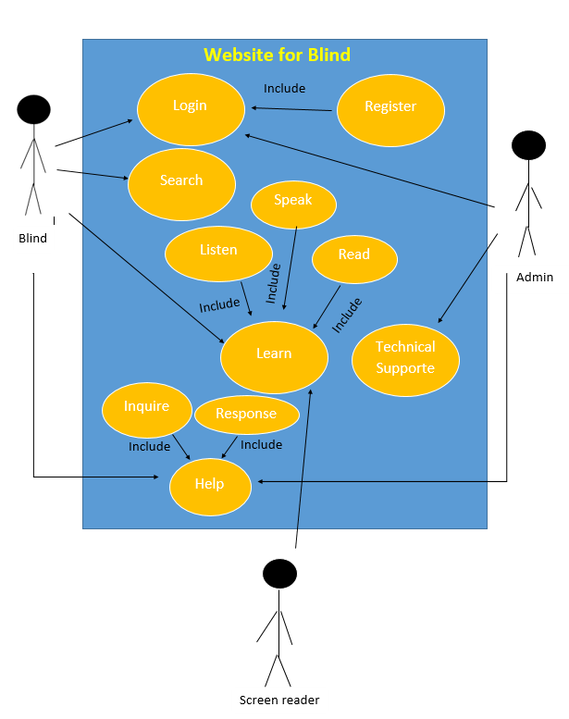**High Level Use Cases**

**Use Case Descriptions**

**1- Use case (Register)**

|  |  |
| --- | --- |
| **ID:** | B001 |
| **Use case name:** | Register |
| **Actor(s):** | Blind ,Admin |
| **Description:** | Blind or Admin create account |
| **Triggering Event** | Blind or Admin click “Register” button in the web sit |
| **Preconditions:** | Blind or Admin needs to have internet access on web sit |
| **Postconditions:** | Blind or Admin have successfully created account |
| **Steps Performed**: | 1- Open web sit with help screen reader  2- Blind or Admin enters his name with help screen reader  3- Blind or Admin enters Username and Password and E-mail and SSN with help screen reader  4- Blind or Admin enters his Birth date with help screen reader  5- Click on “Create Account” button with help screen reader  6- Validation of entered data by web sit |
| **Information for Steps:** | Name, Username, Password, E-mail, SSN |
| **Extensions (Alternative Flows):** | If Blind or Admin entered a non-valid data, a warning Voice message should appear to him. |

**2-Use case (Login)**

|  |  |
| --- | --- |
| **ID:** | B002 |
| **Use case name:** | Login |
| **Actor(s):** | Blind ,Admin |
| **Description:** | Blind or Admin login to his account |
| **Triggering Event** | Blind or Admin click “Login” button in web sit |
| **Preconditions:** | * Blind or Admin needs to have internet access on website. * Blind or Admin needs to have account. |
| **Postconditions:** | Blind or Admin have successfully login account |
| **Steps Performed**: | 1- Open website with help screen reader.  2- Blind or Admin enters E-mail and password with help screen reader.  3- Click on “Login” button with help screen reader.  4- Validation of entered data by web sit |
| **Information for Steps:** | Password, E-mail |
| **Extensions (Alternative Flows):** | If Blind entered a non-valid data, a warning Voice message should appear to him. |

**3-: Use case (Search)**

|  |  |
| --- | --- |
| **ID:** | B003 |
| **Use case name:** | Search |
| **Actor(s):** | Blind |
| **Description:** | Blind search on web site about Educational Materials |
| **Triggering Event** | Blind click “search” button in the web sit |
| **Preconditions:** | * Blind needs to have internet access on web sit * Blind needs to login in to his account |
| **Postconditions:** | Blind have successfully searched about Educational Materials |
| **Steps Performed**: | 1- Open web sit  2- Blind logins on web site and presses the buttons with help screen reader.  3- Blind enters Name Educational Material with the help of a screen reader, the blind spoke while entering the data  4- Click on “search” button with help screen reader  5- Validation of entered data by web sit |
| **Information for Steps:** | Name Educational Materials |
| **Extensions (Alternative Flows):** | If Blind entered a non-valid data, a warning Voice message should appear to him. |

4- **Use case (Learn)**

|  |  |
| --- | --- |
| **ID:** | B004 |
| **Use case name:** | Learn |
| **Actor(s):** | Blind **,** Screen reader |
| **Description:** | Blind learn on web sit about Educational Materials by listen and speak and read with Screen reader |
| **Triggering Event** | Blind click on screen reader button to help for him in the web sit |
| **Preconditions:** | * Blind needs to have internet access on web sit * Blind needs to login in to his account * Blind needs to search about Name Educational Material which he would like to learn |
| **Postconditions:** | Blind have successfully learned about Educational Materials by listen and speak and read with Screen reader |
| **Steps Performed**: | 1- Open web sit  2- Blind logins on web site and presses the buttons with help screen reader.  3- Blind searchs about Name Educational Material with the help of a screen reader, the blind spoke while entering the data  4- Blind learns about Educational Material By watching videos, listening to audio clips, and helping a screen reader  4- Click on “screen reader” button while learning educational materials and help him in Browse Website |
| **Information for Steps:** | Educational Materials |
| **Extensions (Alternative Flows):** | If Blind entered a non-valid data, a warning Voice message should appear to him. |

**5- Use case (Technical support)**

|  |  |
| --- | --- |
| **ID:** | B005 |
| **Use case name:** | Technical support |
| **Actor(s):** | Programmer(Admin) |
| **Description:** | Programmer(Admin) Solve technical problems of the site |
| **Triggering Event** | Blind Call Technical Support by (telephone or message internet) |
| **Preconditions:** | * Programmer (Admin) needs to have internet access on web sit * Programmer (Admin) needs to have knowledge of front end and back end and have experience and Skill technical |
| **Postconditions:** | Programmer have successfully Solved technical problems of the site |
| **Steps Performed**: | He repair and solve technical problems of the site. |
| **Information for Steps:** | Code HTML, CSS, Java script ,PHP , Skill technical |
| **Extensions (Alternative Flows):** | If the blind did not call the programmer to solve the problem within the site, the problem will not be solved and the site will remain broken and they will not be able to learn on it. |

**6- Use case (Help)**

|  |  |
| --- | --- |
| **ID:** | B006 |
| **Use case name:** | Help |
| **Actor(s):** | Admin ,Blind |
| **Description:** | Blind inquires about problem and responses on it by Admin by speaking |
| **Triggering Event** | Blind speaks in Dialog Box for inquiries about problem |
| **Preconditions:** | * Blind needs to have internet access on web sit * Blind needs to have problem for inquiries |
| **Postconditions:** | Blind have successfully inquired about problems and responses on it by Admin by speaking |
| **Steps Performed**: | * Open web sit. * Blind writs in Dialog Box about problem by speaking. * Admin responses on it. |
| **Information for Steps:** | Problems |
| **Extensions (Alternative Flows):** | If Blind entered a non-valid data, a warning Voice message should appear to him. |

.

**5. USER EXPERIENCE WIREFRAMES**

Initial prototype screens to validate initial understanding of the product.

**6. PROJECT ORGANIZATION**

Breakdown of major tasks and schedule

**Matrix of Responsibilities**

Defines the high level which team members are responsible for which tasks

**PERT / Gantt Chart**

First cut at schedule

**7. VALIDATION PLAN**

**Test Strategy**

What is the definition of done?

What does success look like?

**8. FEASIBILITY STUDY**

What are the known risks and how will they be handled?

**Risk Identification**

Description of the risks

**Risk Prioritization**

Prioritized list (biggest risk -> lowest risk)

**Risk Mitigation**

How will risk factors be addressed? By when?

What are you going to prototype?

**9. CONFIGURATION AND VERSION CONTROL**

Specify the process and attributes for version control for all project and product artifacts

**10. TOOLS**

Provide a list of tools required for the project and their use

**11. ARCHITECTURE**

List of hardware or other subsystems required for the product.